**Appendix B: Example Problem**

The following is an example problem that an engineer may encounter in their daily work that involves the designing of a cam to meet a selected follower motion displacement. This appendix will show the step by step instructions for how this problem is solved using this program and will additionally show the features of the overall program in a detailed manner.

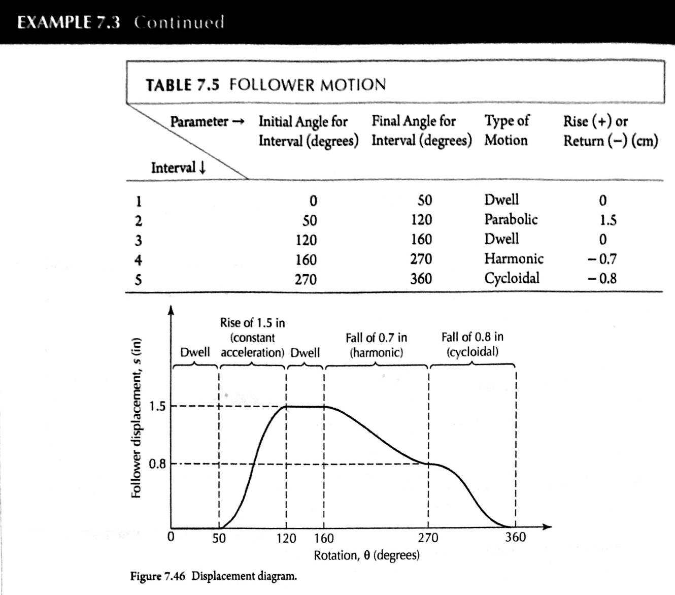

Additional Needed Information Not Included in Screenshot:

* Starting Radius of 4.0 cm
* Angular Velocity of 1 rad/s

When the user first starts the program, this is the menu they encounter. In this example, since there is not an existing Cam Profile File yet, the user will select the first option to Generate a New Cam Profile.

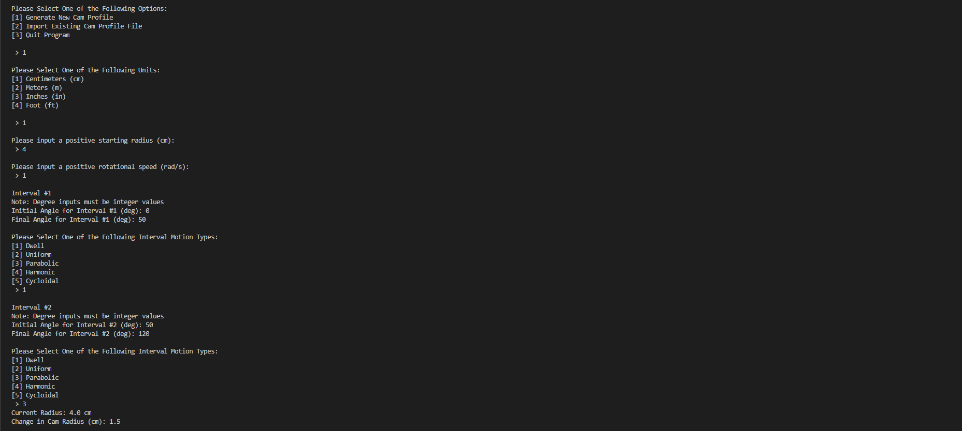

Once the user has selected this option, they will then be met will the following units menu. In this example, the units used in the problem are Centimeters, so the user will select the first option



The user will then be met with the option to input the starting radius and angular velocity. In this problem, the starting radius and angular velocity are 4 cm and 1 rad/s respectively



The user will then be met with this screen where they will enter 50 for the final angle of the first interval. Additionally, as the example states, this interval follows the Dwell motion type; therefore, the user will select the first option. It should noted that since this is a Dwell, the user is not prompted to input a rise or run value since Dwell always have a change of radius of 0.



For the second interval, the user will input 120 degrees as the final angle and will then select the third option for the Parabolic motion type. Unlike the first interval, the user will now be prompted to input a change of radius since this motion type intrinsically has a rise or return.



For the third and fourth interval, the user will continue to input the final angles and select the motion type for each interval. It should be noted that as seen in interval four, the user can input a negative change in radius to indicate a return

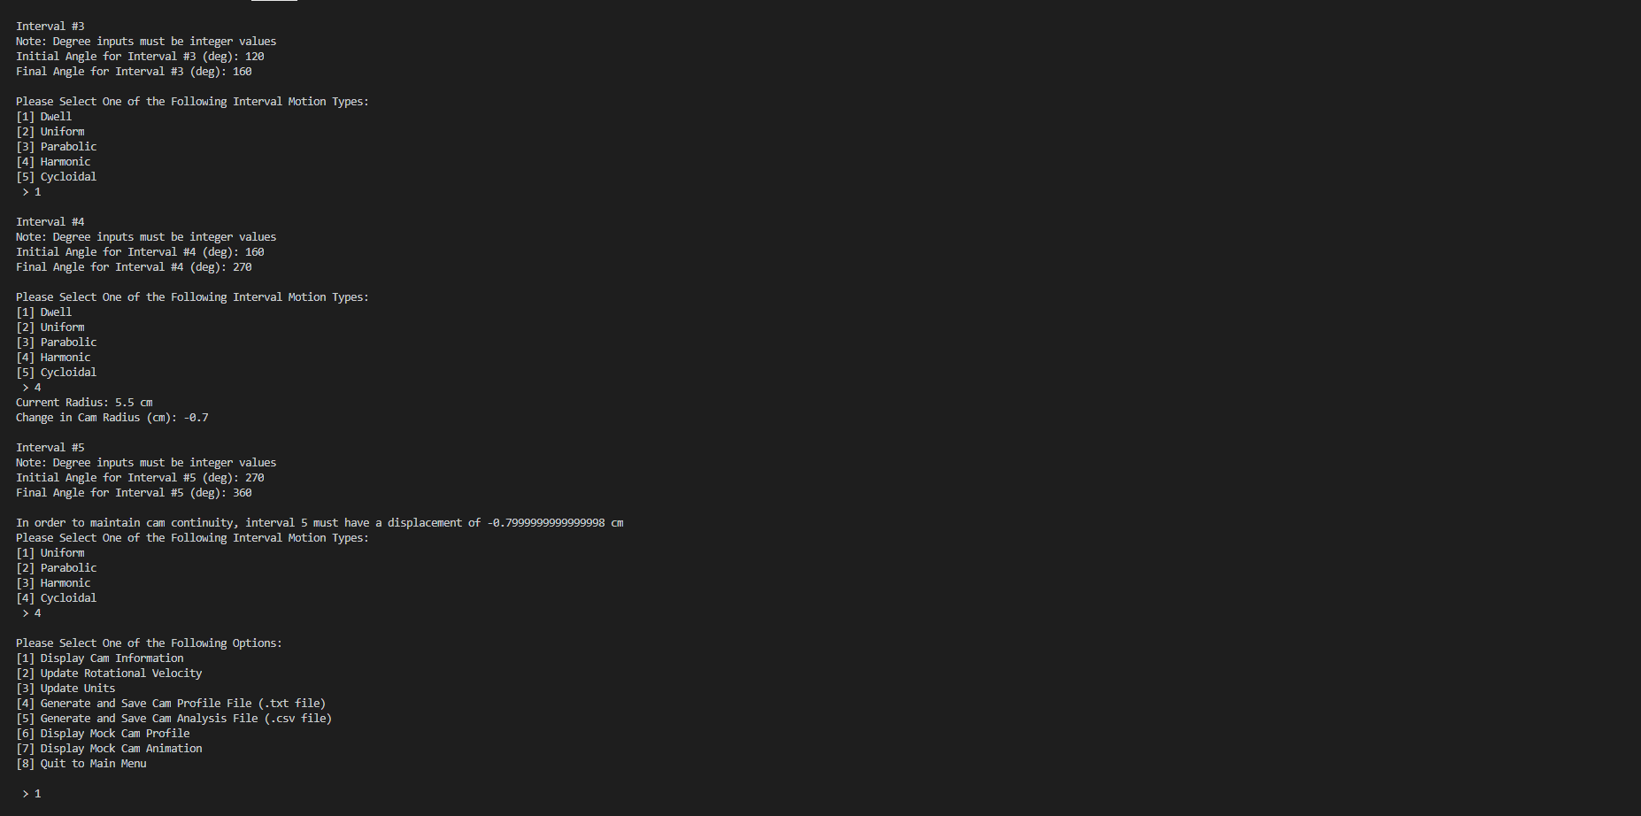

For the fifth and final interval, the user will input 360 as the final angle for the interval. At this point, the program will prompt the user to select a motion type with an inherent and predefined displacement so that the cam profile maintains a continuous profile. In the cases where the current radius is equivalent to the starting radius, the program will automatically select the Dwell motion type for the user.



Once the user has generated or imported a cam profile, they will then be met with this menu. In the following sections of this example, the functionality of each option will be shown.



The first option of the menu displays the defining characteristics of the cam. This is useful in situations where the user has imported a file and wants to see how the cam is defined.

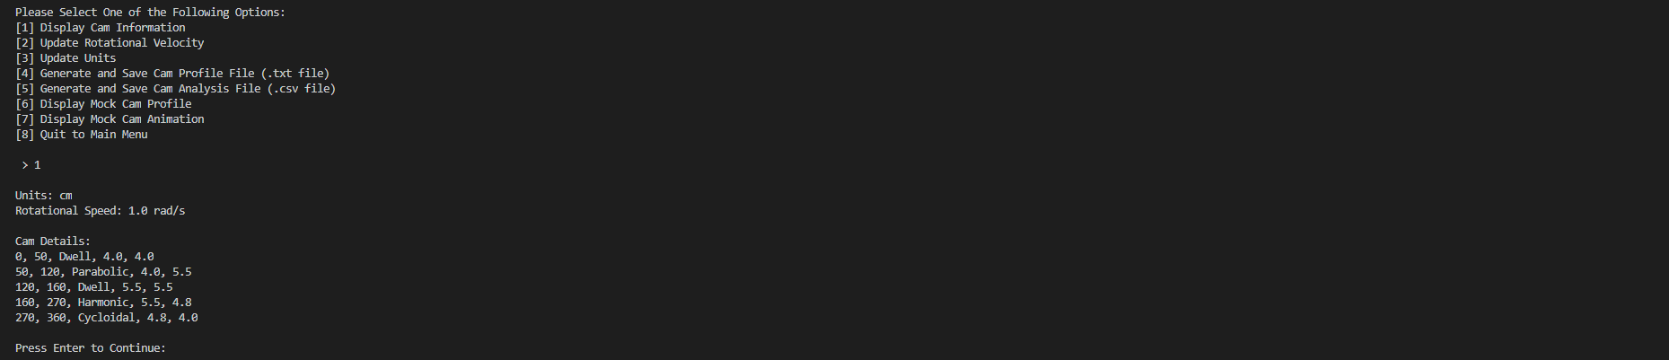

The second option allows for the user to change the rotational velocity of the cam. The effects of this change in rotational velocity can be seen in the results exported to the .csv file in option 5 since the time, follower velocity, follower acceleration, and follower jerk for each angle of the cam are all dependent on the angular velocity of the cam.

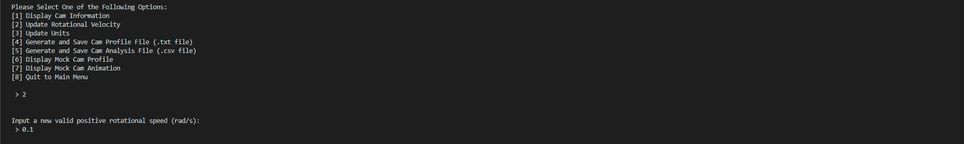

Option 3 of the menu allows the user to update the units of the profile. This function is mainly useful for situations where the user made a mistake in inputting their information during the generation stage or imported an old cam profile with outdated units.

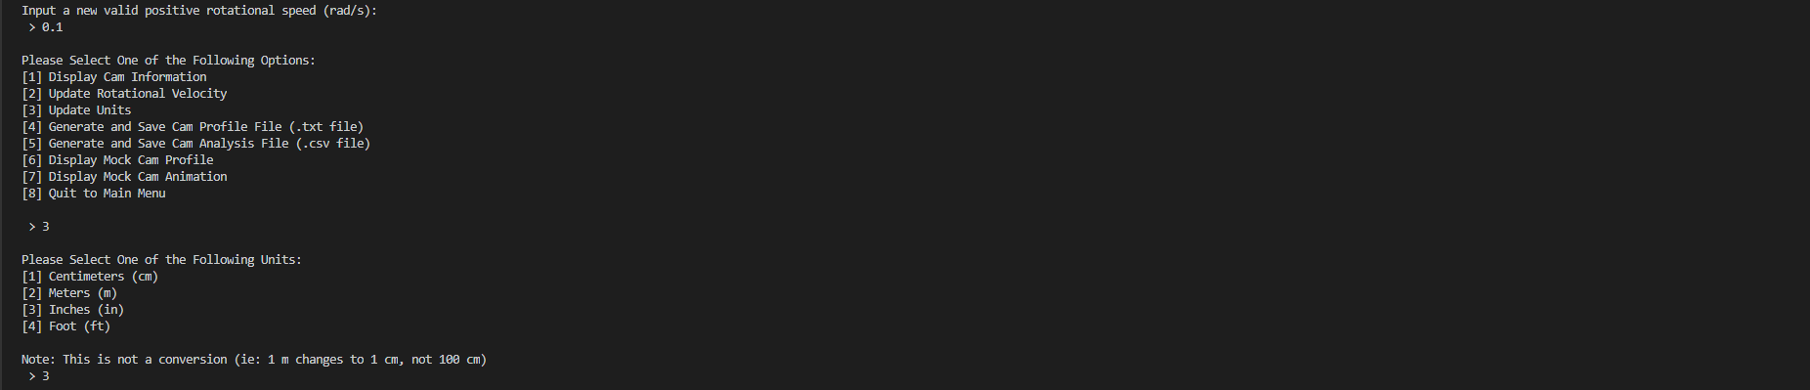

The fourth option creates a .txt file that can later be imported for future analysis.

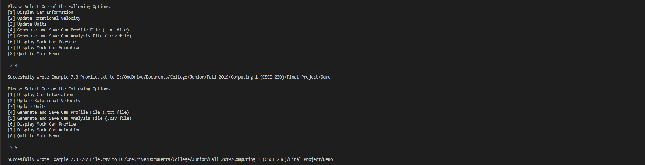

After the user selects this option, they are met with the following dialog box. It should be noted that the initial file name for the .txt includes the date and time so that saved files cannot be overwritten due to the user not changing the initial filename.

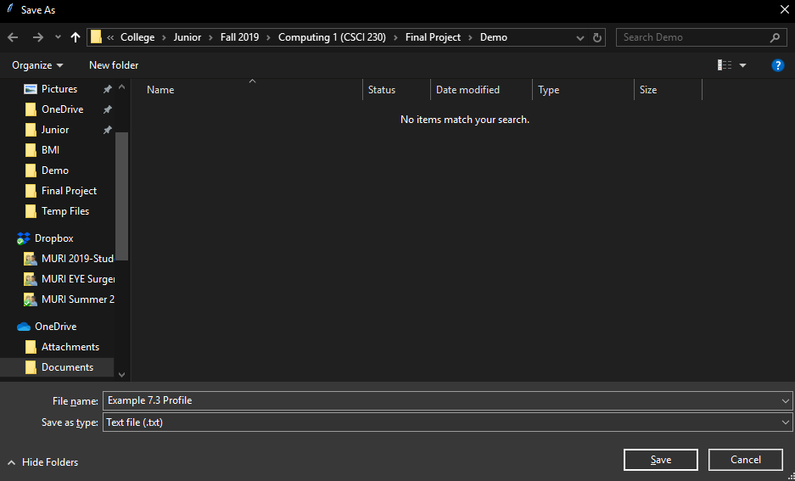

The following is the .txt file that the program exported.

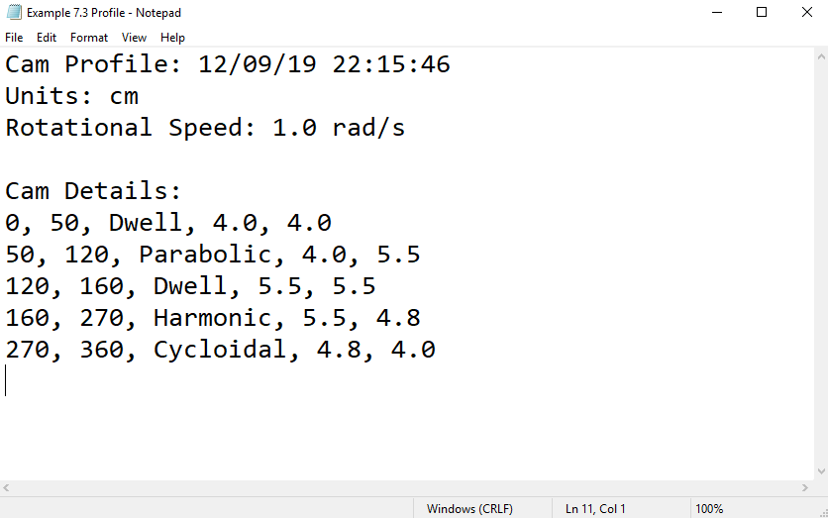

Similar to the fourth option, the fifth option allows the user to generate a .csv file that contains the angular position, time, follower position, follower displacement, follower velocity, follower acceleration, and follower jerk for every integer degree of cam rotation.



After the user selects this option, they are met with the following dialog box. Similar to the .txt file saving option, the initial file name includes the date and time so that saved files cannot be overwritten due to the user not changing the initial filename.

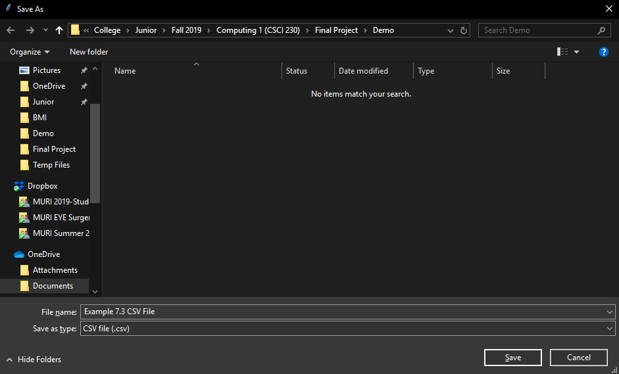

The following is a section of the .csv file that the program exported.

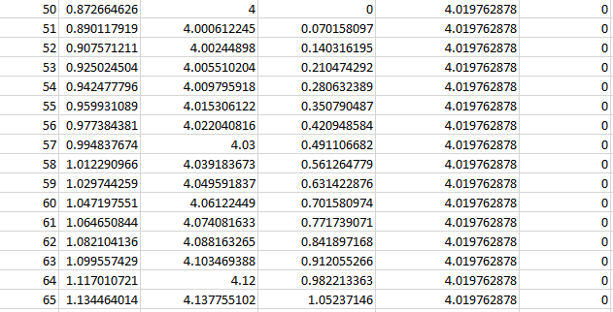

The following are graphs that the user could potentially create on their own using the data from the .csv file that the program exports.

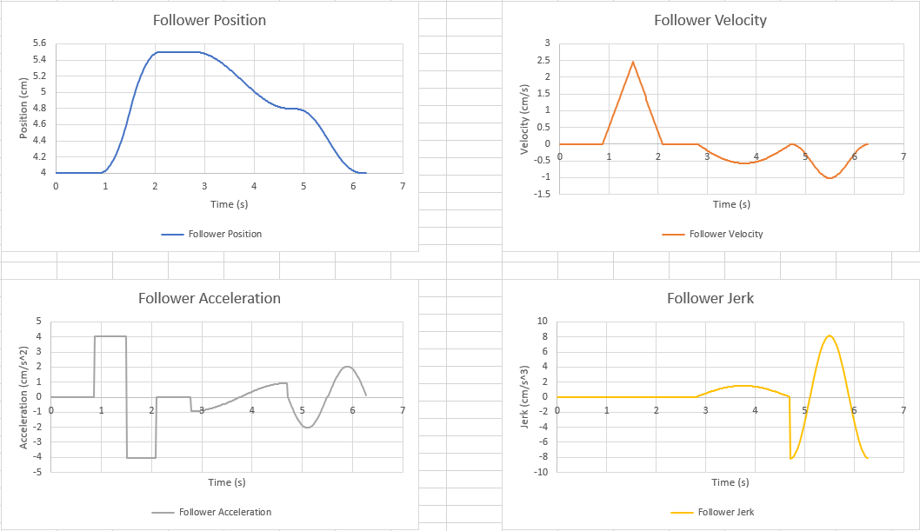

The sixth option launches a tkinter window that draws a static image of the cam profile

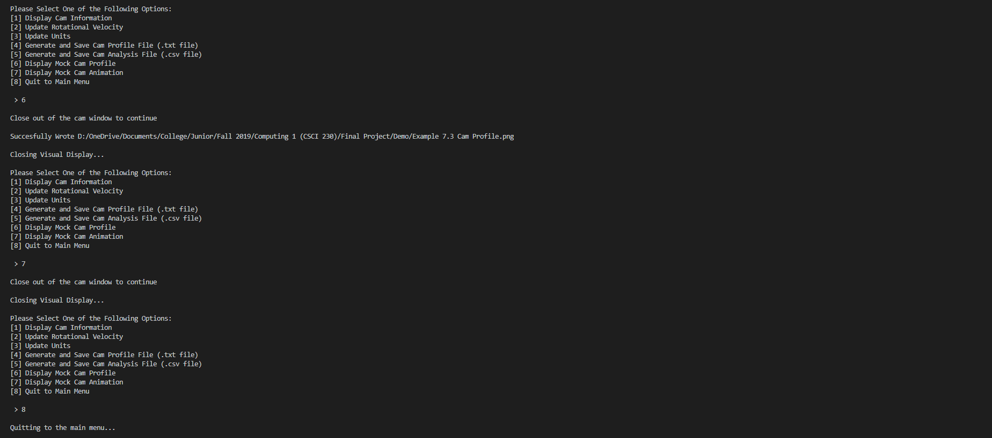

The following is the cam profile created from the example. Using the save button, the user can export the cam profile as a .png file.

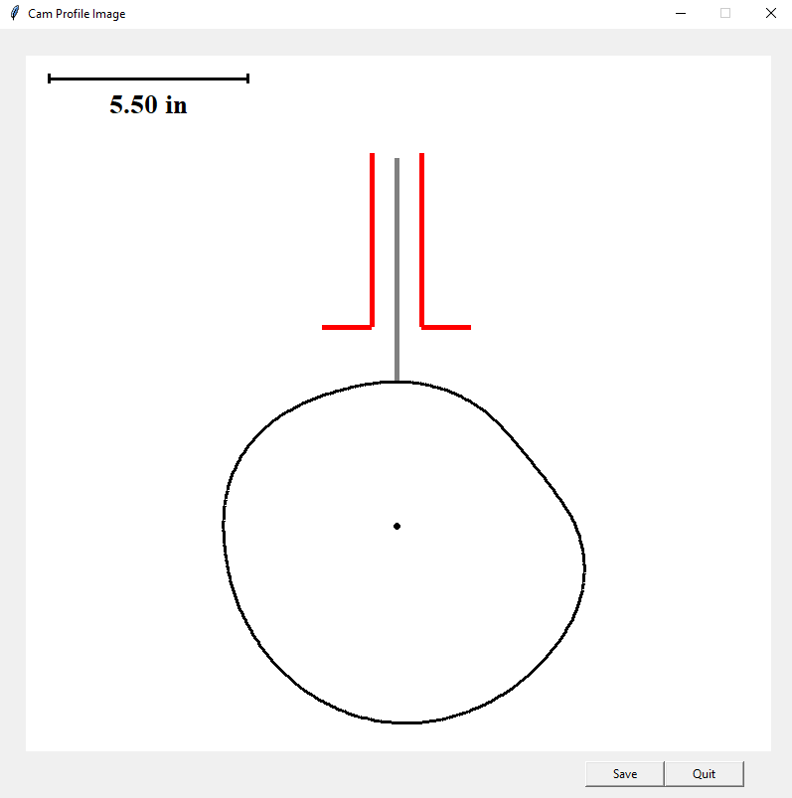

The following is the dialog box that opens when the user opts to save the cam profile. Similar to the .csv and .txt file saving method, the initial file name includes the date and time so that older image outputs cannot be overwritten due to the user not changing the default filename.

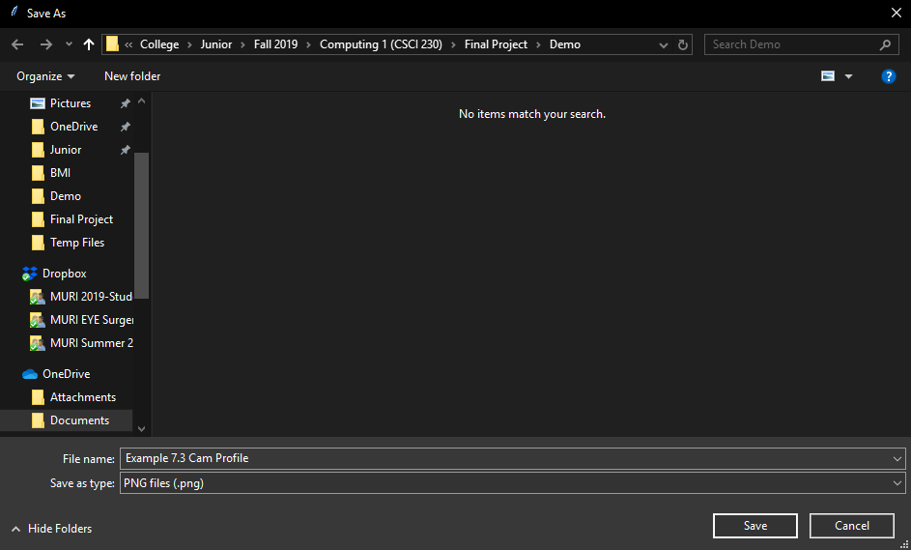

The following is the .png file that the program exports via the sixth option.

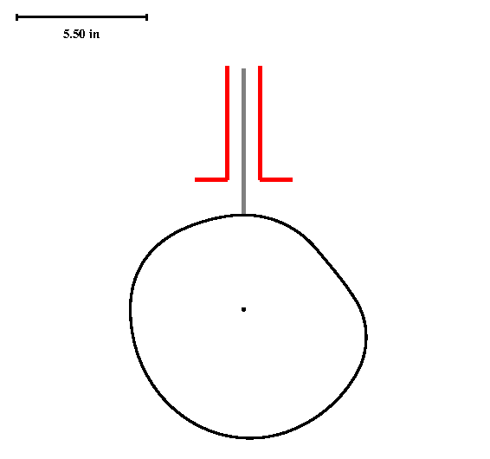

When the user selects the seventh option, a similar tkinter window opens. However, this time the window shows a brief animation of the cam rotating. Due to how the cam is drawn, the animated rotation of the cam is not dependent on the angular velocity but is rather limited by processing and rendering power.



The following is a screenshot of the cam rotating. It should be noted that during this time, the Play Again and Quit button are disabled so that the user does not cause the program to crash during the cam animation.

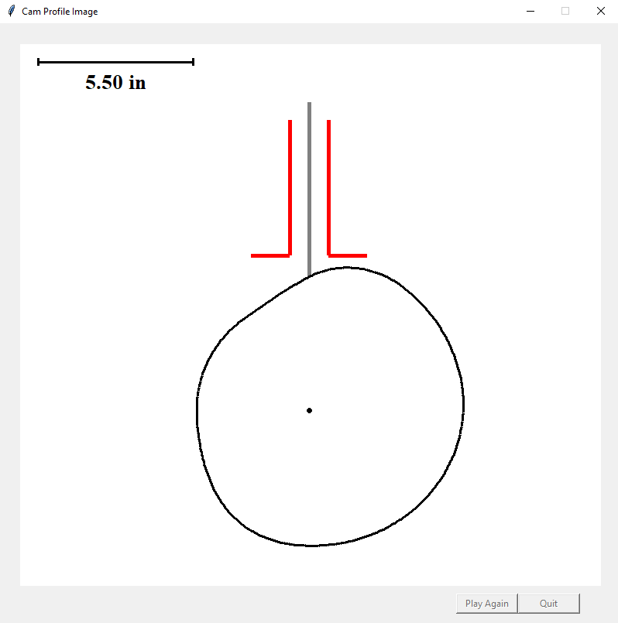

Once the user is done analyzing the cam, they can select the eighth option to return to the main menu.



Alternatively, if the user has a preexisting cam profile .txt file, they can import that cam profile from the main menu using the second option.

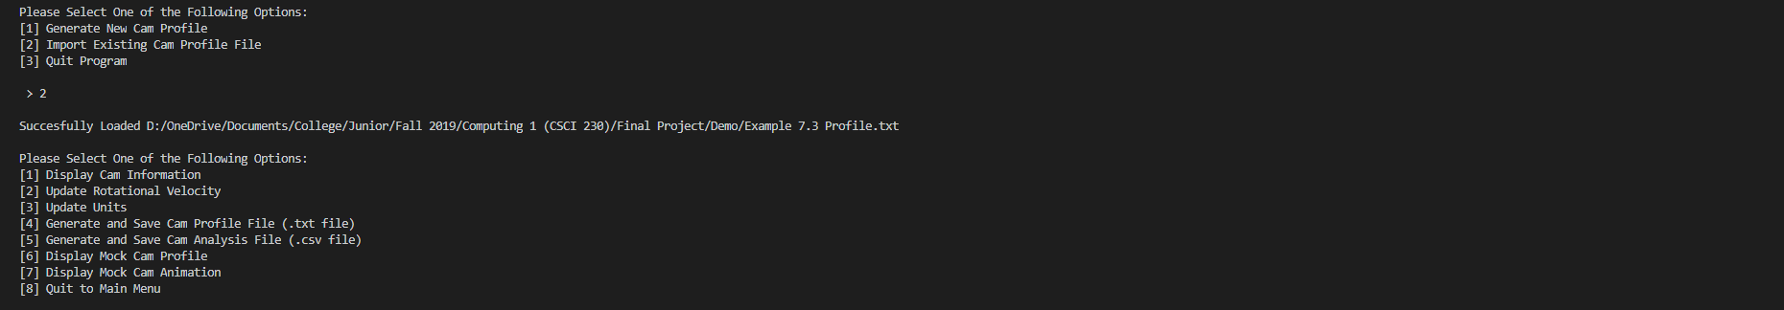

The following is the dialog box that opens when the user selects to import the cam profile .txt file.

